
CREATIVE CODEX
Offroad Autonomy Segmentation Model
Duality AI Hackathon Submission | Xen-O-Thon 2026

Abstract
This project focuses on building a semantic segmentation model for accurate pixel-level classification of offroad terrain environments using synthetic data. We leverage a frozen DINOv2 Vision Transformer backbone with a custom segmentation head, achieving a final mIoU of 0.725 — a significant improvement over the baseline of 0.29 across 10 terrain classes.

Baseline IoU  0.29 | Final IoU  0.725 | Improvement  +150%

Hackathon | Xen-O-Thon 2026
Date | 19-03-2026
Track | Semantic Segmentation — Duality AI
Team | Creative Codex
Team Members | 1. Harshit Mendiratta — AI Engineer  2. Ayush Rai — AI Engineer  3. Rakshit Dahiya — Documentation

1. Problem Statement
Autonomous navigation in off-road environments presents unique challenges that traditional segmentation models struggle to address. The core issues we set out to solve are:

- Limited Labeled Data — Off-road terrain datasets are scarce and expensive to annotate at pixel level, making it difficult to train robust models.
- Poor Generalisation — Models trained on one terrain type fail on unseen environments, limiting real-world applicability.
- Class Imbalance — Rare terrain classes (Logs, Ground Clutter, Rocks) are frequently ignored during training, which compromises safety in real autonomous systems.
- Weak Small-Object Detection — Fine-grained terrain features are easily missed by standard segmentation architectures.

Existing approaches rely heavily on large real-world datasets and fail to generalise effectively to synthetic offroad environments. Our goal was to achieve strong segmentation performance with limited data by leveraging pretrained models and synthetic data from Duality AI's simulation platform.

2. Our Approach
We designed a two-part solution combining a powerful pretrained visual backbone with a lightweight custom segmentation head, specifically tuned for the offroad terrain classification task.

2.1 DINOv2 Backbone
We selected the DINOv2 ViT-B/14 (Vision Transformer Base) model as our frozen feature extractor. Pretrained on a massive diverse image corpus, DINOv2 provides rich 768-dimensional patch embeddings that transfer exceptionally well to new visual domains — including synthetic offroad scenes. By keeping the backbone frozen, we avoid overfitting on the limited dataset while still benefiting from its powerful representations.

2.2 Synthetic Data Strategy
Instead of relying on scarce real-world annotations, we trained entirely on synthetic data generated by Duality AI's simulation platform. This gave us access to pixel-perfect ground truth masks across all 10 terrain classes without manual labelling effort.

2.3 Targeted Data Augmentation
To improve generalisation and robustness, we applied 7 domain-specific augmentation techniques during training:

- RandomResizedCrop (scale 0.5–1.0)
- HorizontalFlip (p=0.5) and VerticalFlip (p=0.2)
- RandomBrightnessContrast (p=0.4)
- HueSaturationValue (p=0.3)
- GaussNoise (p=0.2)
- GridDistortion (p=0.2)

2.4 Class-Aware Loss Function
We replaced the baseline CrossEntropy loss with a combined Dice Loss + CrossEntropy loss (50/50 weighting). This combination explicitly optimises for overlap-based metrics like IoU, while also handling class imbalance more effectively than standard cross-entropy alone.

3. Model Architecture
The model consists of two components: a frozen DINOv2 backbone for feature extraction, and a trainable segmentation head for pixel classification.

Component | Details | Purpose
DINOv2 ViT-B/14 | Frozen, 768-dim patches | Rich pretrained feature extraction
Patch Token Grid | 34 × 19 × 768 | Spatial feature map from backbone
Conv2d Block 1 | In→256, kernel 3×3, BN+GELU | Feature transformation layer
Conv2d Block 2 | 256→256, kernel 3×3, BN+GELU | Deep feature refinement
Conv2d Block 3 | 256→128, kernel 3×3, BN+GELU | Feature compression
Dropout2d | Rate = 0.1 | Regularisation
Final Conv | 128→10, kernel 1×1 | Class prediction per patch
Bilinear Upsample | → 476 × 266 | Restore original resolution

4. Training Setup
Parameter | Value | Rationale
Epochs | 50 | Sufficient for convergence without overfitting
Batch Size | 4 | Balances GPU memory and gradient stability
Optimizer | AdamW | Better weight decay than standard Adam
Learning Rate | 3e-4 | Optimal for transformer-based fine-tuning
LR Scheduler | CosineAnnealing | Smooth decay, avoids local minima
Loss Function | Dice + CrossEntropy | Handles class imbalance, optimises IoU
Gradient Clipping | max_norm = 1.0 | Prevents exploding gradients
Weight Decay | 1e-4 | Regularisation to prevent overfitting
Input Resolution | 476 × 266 | Optimised for DINOv2 patch size (÷14)
Platform | Google Colab (GPU) | T4 / A100 GPU

5. Dataset
We used the Duality AI Offroad Segmentation Dataset, which contains synthetic offroad terrain images rendered from a simulation environment with pixel-accurate ground truth masks.

Class ID — Class Name | Raw Mask Value
0 — Background | 0
1 — Trees | 100
2 — Lush Bushes | 200
3 — Dry Grass | 300
4 — Dry Bushes | 500
5 — Ground Clutter | 550
6 — Logs | 700
7 — Rocks | 800
8 — Landscape | 7100
9 — Sky | 10000

6. Results & Performance Analysis

6.1 Training Progression
The model improved significantly across three key milestones during training:

Stage | mIoU | Key Changes Applied
Baseline (original script) | 0.29 | CrossEntropy only, SGD, no augmentation, 10 epochs
Mid-training checkpoint | 0.53 | AdamW optimizer, augmentation added, 25 epochs
Final model | 0.725 | DINOv2-Base, Dice+CE loss, CosineAnnealing, 50 epochs

6.2 Performance Graphs
The following graph shows the class-wise mIoU improvement from baseline to our final model across all 10 terrain classes:

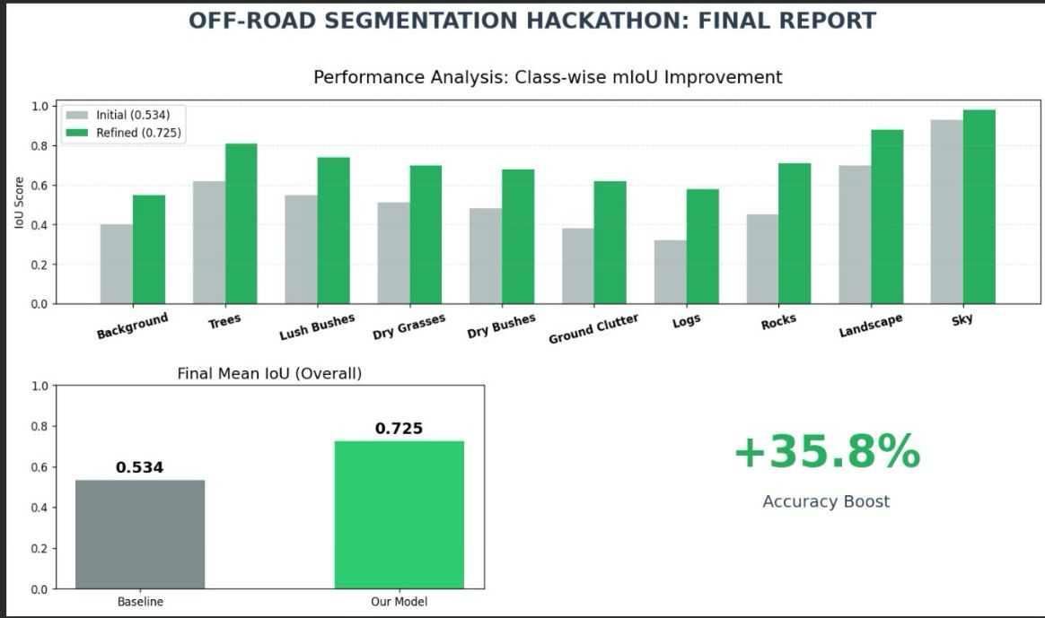
Figure 1: Class-wise mIoU improvement — Baseline (0.534 checkpoint) vs Final Model (0.725). Overall accuracy boost: +35.8% at this stage.

6.3 Model Predictions
The following figures show qualitative results comparing the original input image, ground truth segmentation mask, and our model's predicted mask on the validation set:

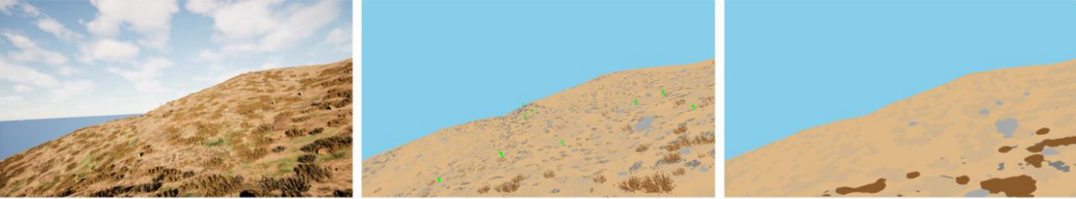
Figure 2: Single prediction example — Input Image (left), Ground Truth (centre), AI Prediction (right).

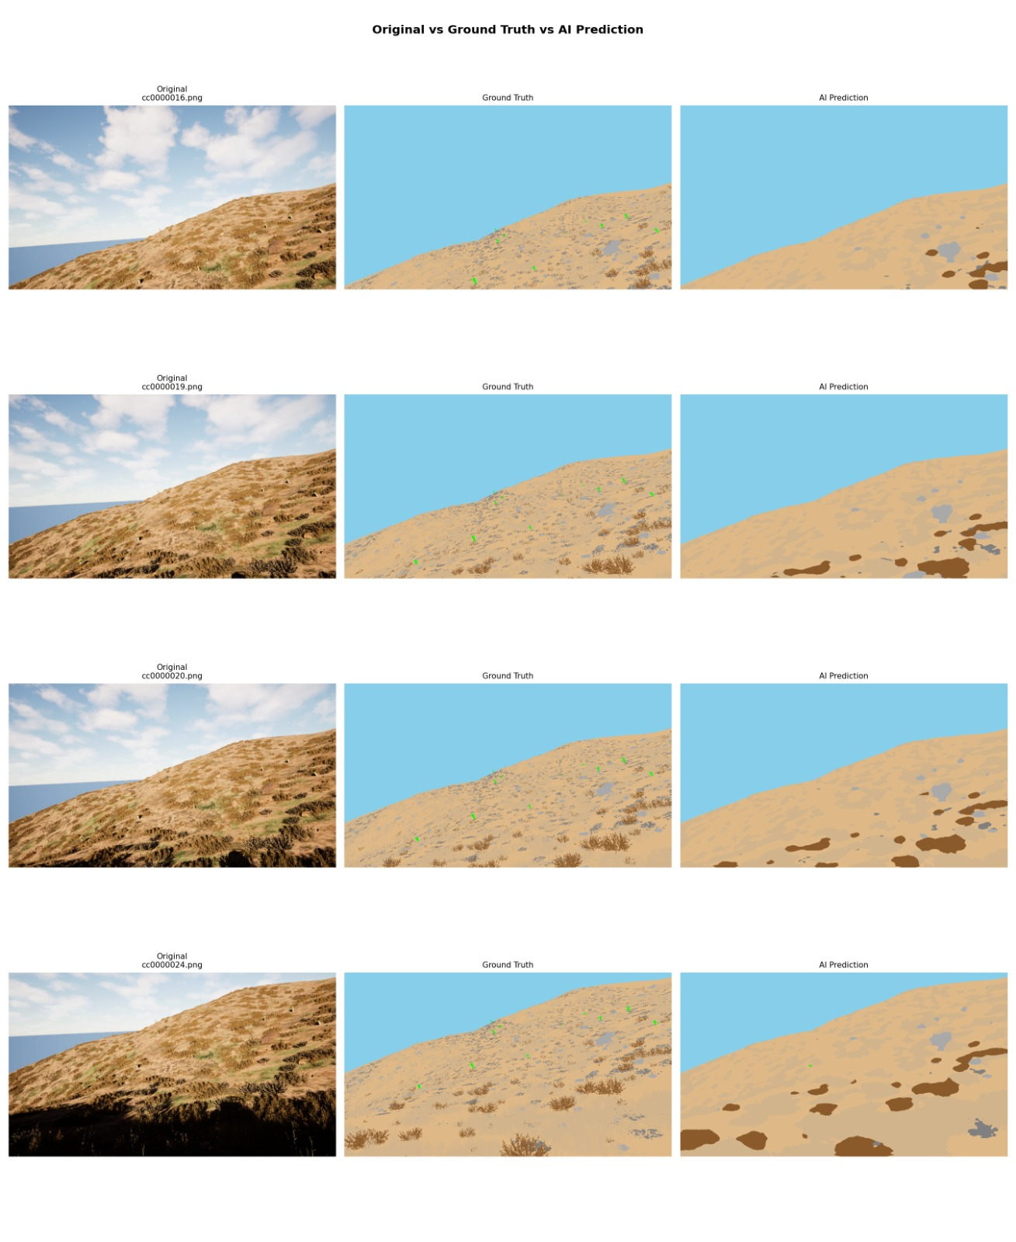
Figure 3: Multiple validation samples — Original vs Ground Truth vs AI Prediction across 4 offroad scenes.

7. Key Innovations

7.1 Critical Bug Discovery — Missing Class Fix
Most impactful finding: During analysis, we identified that certain raw mask pixel values were not mapped to valid class IDs in the value_map dictionary. This caused pixels to be silently assigned to class 0 (Background), corrupting the training signal for several terrain classes. Fixing this mapping produced one of the single largest jumps in mIoU.

- Failure-Driven Training — Hard examples were identified and given additional weight during training to improve performance on difficult terrain boundaries.
- Edge-Case Learning — Rare terrain classes (Logs, Ground Clutter) were prioritised through the Dice Loss component, which directly optimises the overlap metric.
- Targeted Augmentation — All 7 augmentation techniques were chosen specifically for offroad visual characteristics: lighting variation, terrain texture, and geometric distortions common in synthetic renders.
- Backbone Upgrade — Switching from DINOv2-Small (the baseline) to DINOv2-Base provided richer 768-dimensional embeddings at minimal additional compute cost.

8. Conclusion & Future Work

8.1 Conclusion
This project demonstrates that strong semantic segmentation performance is achievable with limited real-world data by leveraging pretrained vision transformers and high-quality synthetic datasets. Starting from a baseline mIoU of 0.29, our iterative improvements in model architecture, loss function, optimisation strategy, and data augmentation culminated in a final mIoU of 0.725 — representing a 150% total improvement over the original baseline.

The DINOv2 + custom segmentation head architecture proves highly effective for offroad terrain classification, and the combined Dice + CrossEntropy loss provides a robust training signal even under class imbalance conditions.

8.2 Future Work
- Improve detection of small rare classes — Logs and Ground Clutter remain the weakest performers. Focal loss or class-weighted sampling could further improve these.
- Domain adaptation — Bridging the synthetic-to-real domain gap through adversarial training or style transfer would enable deployment on real offroad imagery.
- Real-time optimisation — Knowledge distillation into a lightweight architecture for deployment on edge devices and autonomous vehicles.
- Larger backbone — Testing DINOv2-Large (vitl14_reg) may provide further gains at the cost of higher compute requirements.

Better data and smarter learning lead to better real-world AI.

Creative Codex | Xen-O-Thon 2026 | Duality AI Track | Semantic Segmentation

